EMPLOYEE DATABASE ADDITIONAL QUERIES

1. List the name of the managers with the maximum employees

Sql> select ename from employee where mgr_no = (select max(mgr_no) from employee);

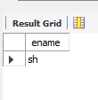

1. Display those managers name whose salary is more than average salary of his employee

Sql> select ename from employee where sal > (select avg(sal) from employee);



1. Find the name of the second top level managers of each department.

Sql> select ename from employee where sal = (select max(sal) from employee where sal < (select max(sal) from

employee));

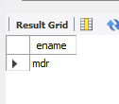

1. Find the employee details who got second maximum incentive in January 2019.

Sql> select * from employee where empno = (select empno from incentives where amt = (select max(amt) from

incentives where amt < (select max(amt) from incentives)));

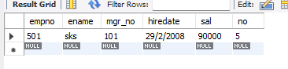

1. Display those employees who are working in the same department where his

manager is working.

Sql> SELECT e1.empno AS EmployeeID, e1.ename AS EmployeeName, e1.no AS EmployeeDeptNo,

e1.mgr_no AS ManagerID, e2.no AS ManagerDeptNo

FROM employee e1

LEFT JOIN employee e2 ON e1.mgr_no = e2.empno;

